[E133] Solid state relays

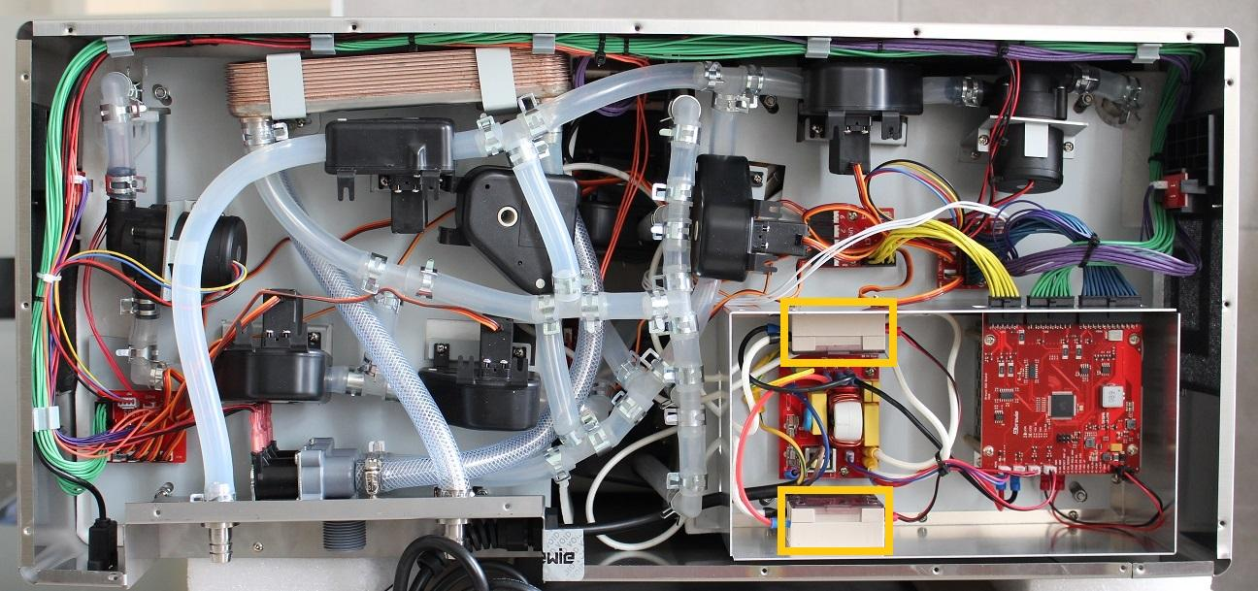

There are two solid state relays (SSRs) in the machine. One is for the mash and one for the boil heater element.

SSR for the mash heater element

In order to remove the mash side SSR first the rear service plate has to be taken out. Unscrew the marked screws (5 pcs) to ease the access to the SSR.

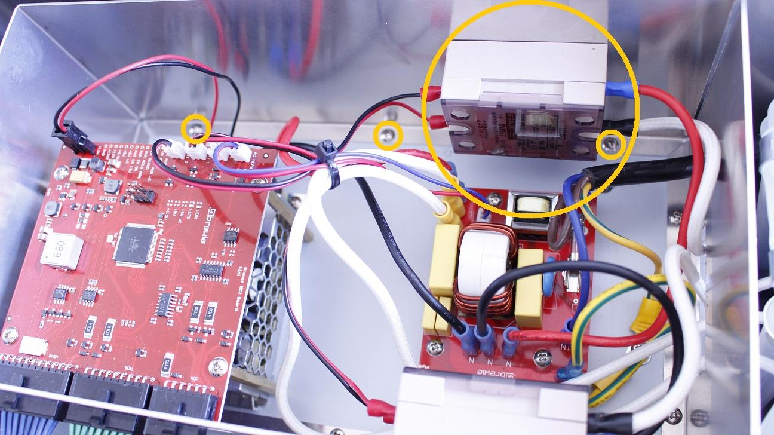

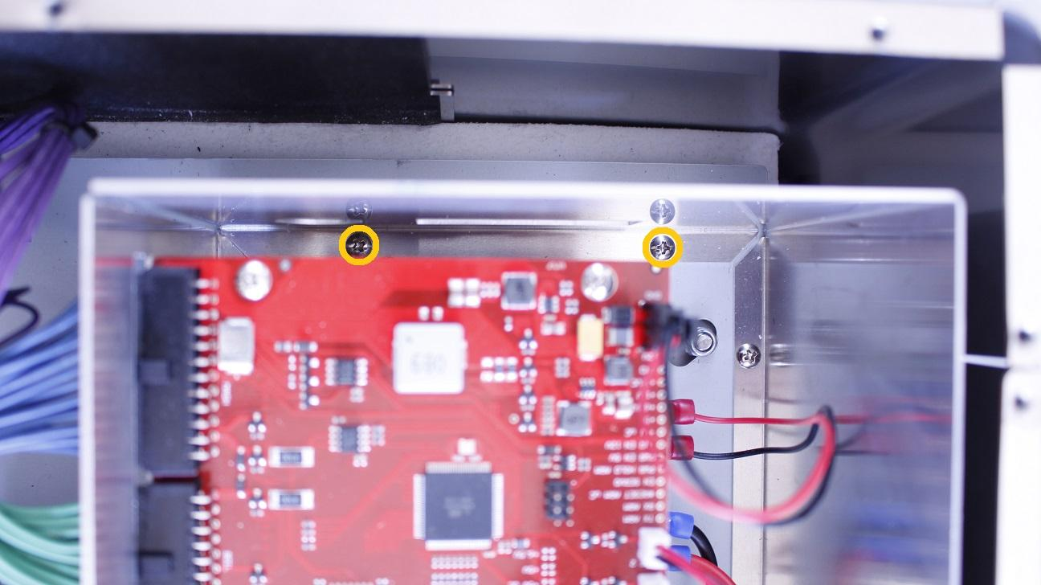

Once the plate can be twisted out, by loosening the indicated screws the cables can be disconnected.

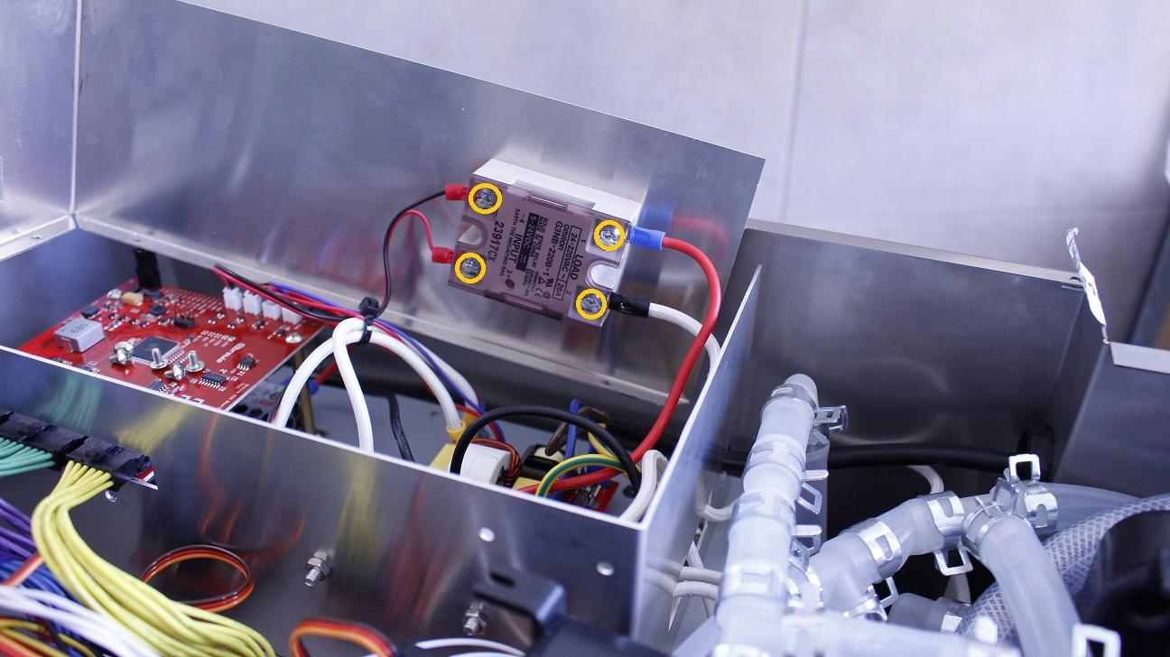

The rear plate can be removed now.

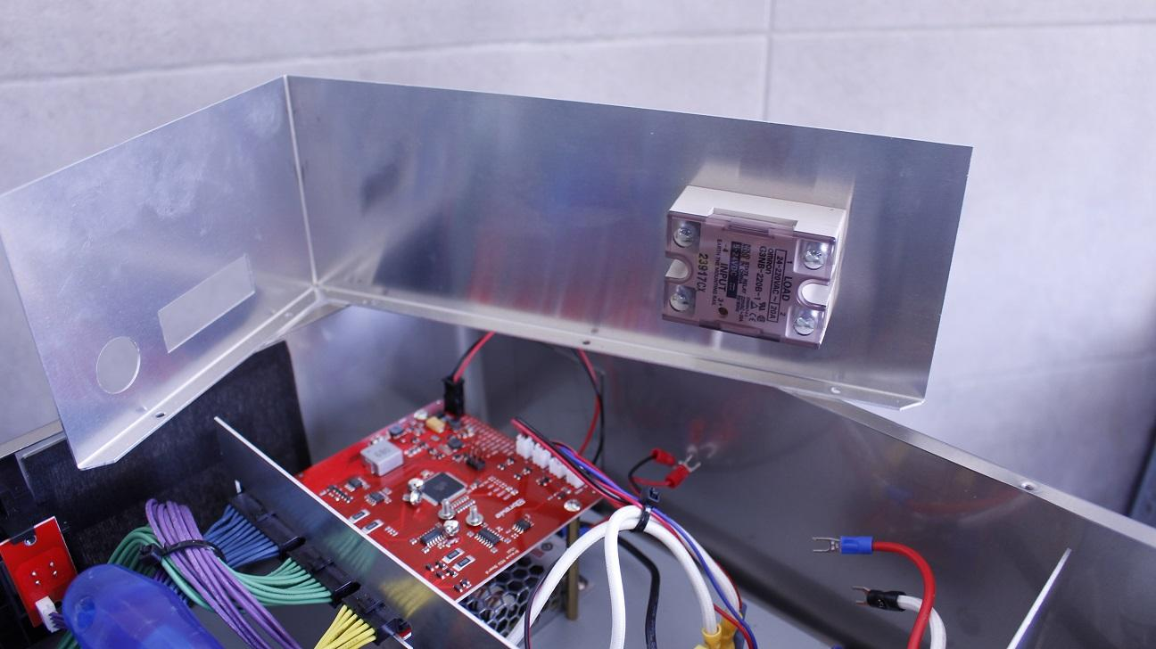

Unscrew the locknuts holding the SSR.

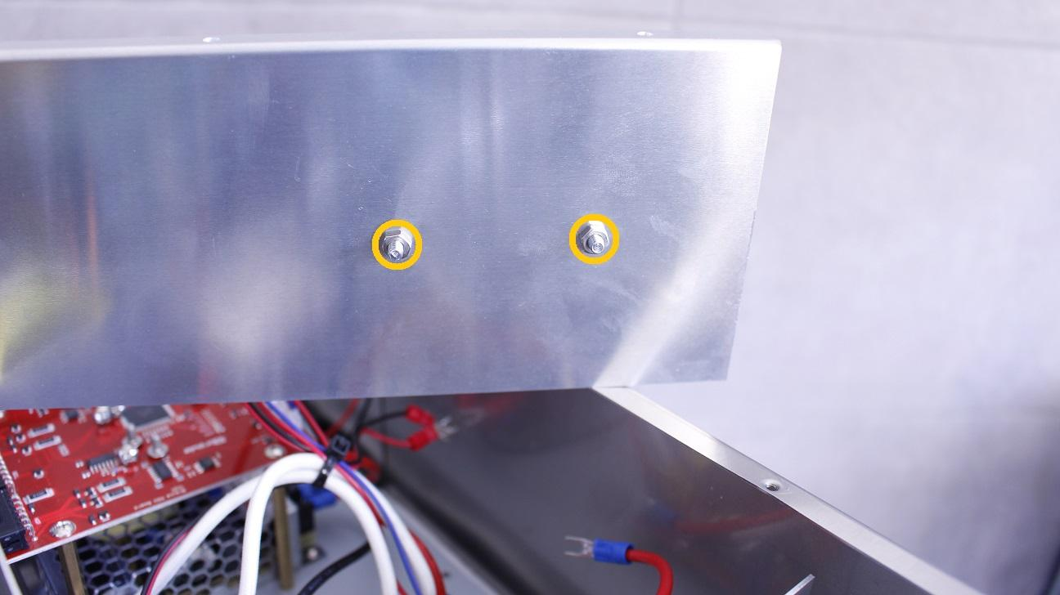

The SSR can be removed now.

Reassemble consists of the same steps in reverse.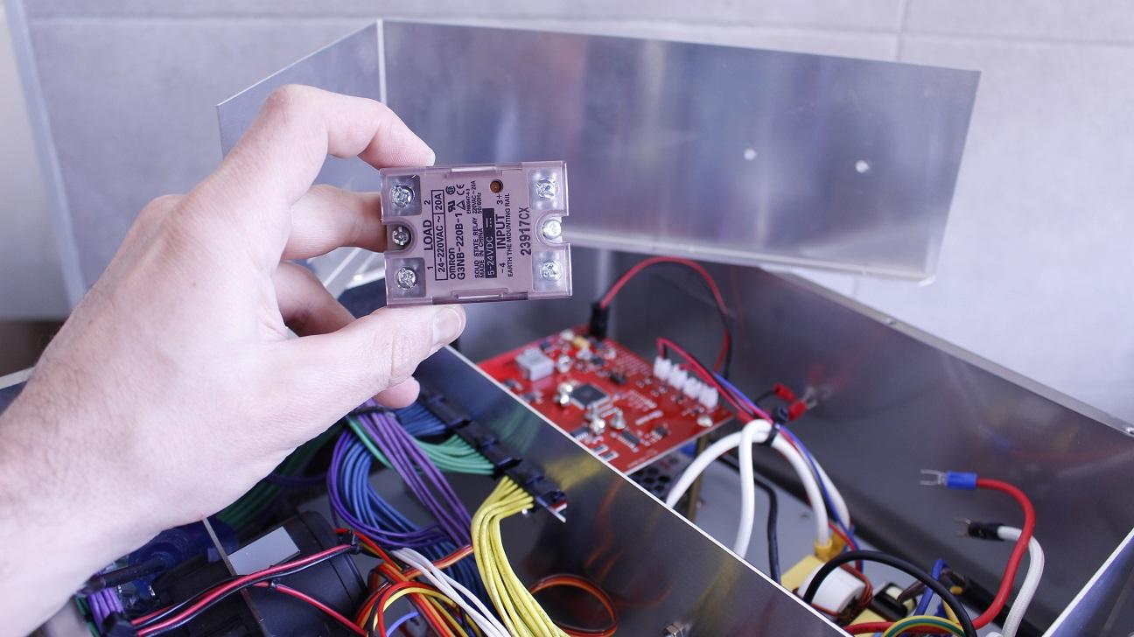

SSR for the boil heater element

The SSR of the boil heater is located on the front service plate.

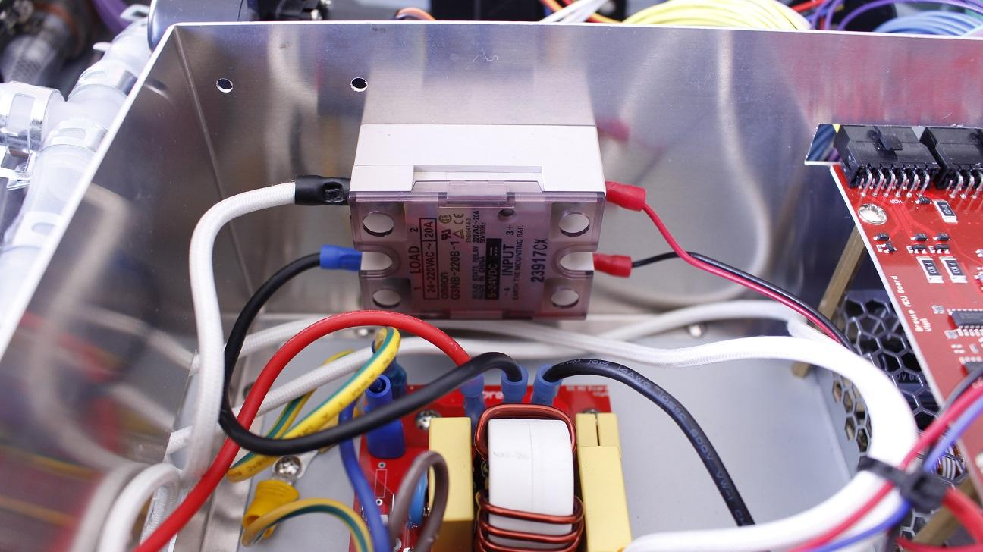

To have access to the holding locknuts, first, the boil inlet valve has to be moved. Unscrew the fastening screws and pull the valve away from the locknuts.

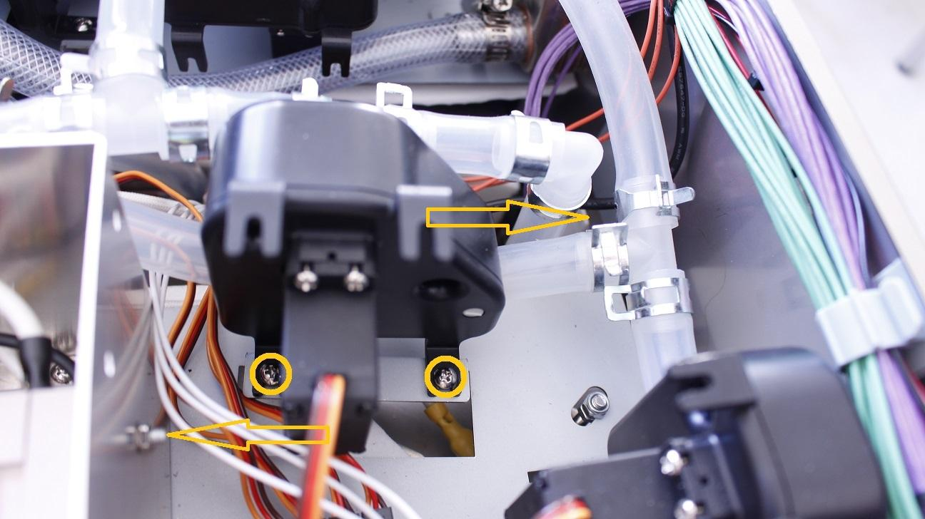

The locknuts can be removed.

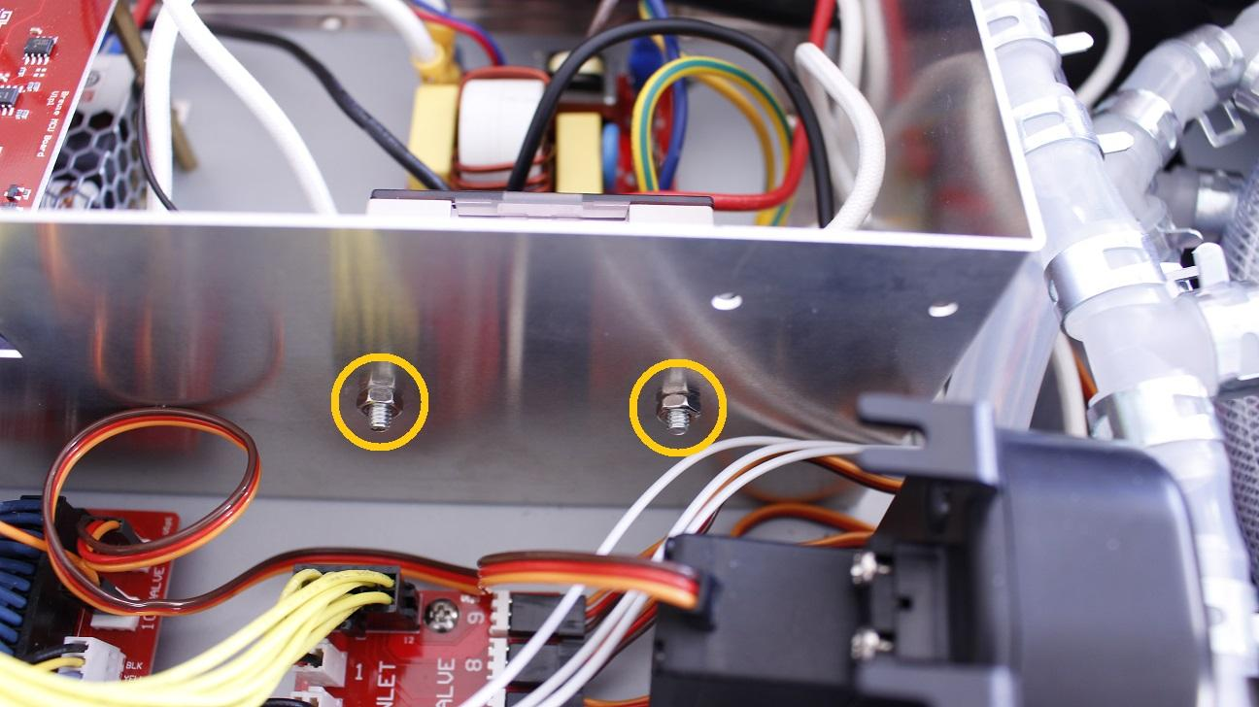

Move the SSR from the plate and disconnect the cables by loosening the indicated screws.

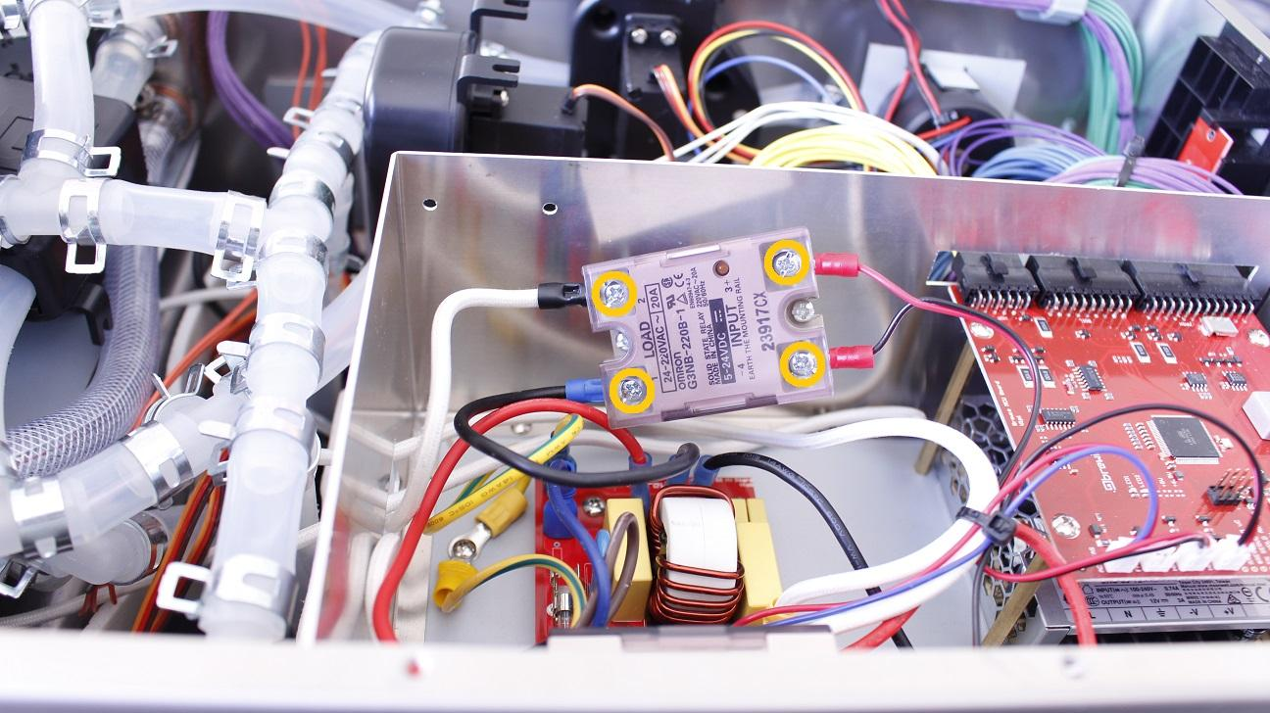

The SSR can be removed.

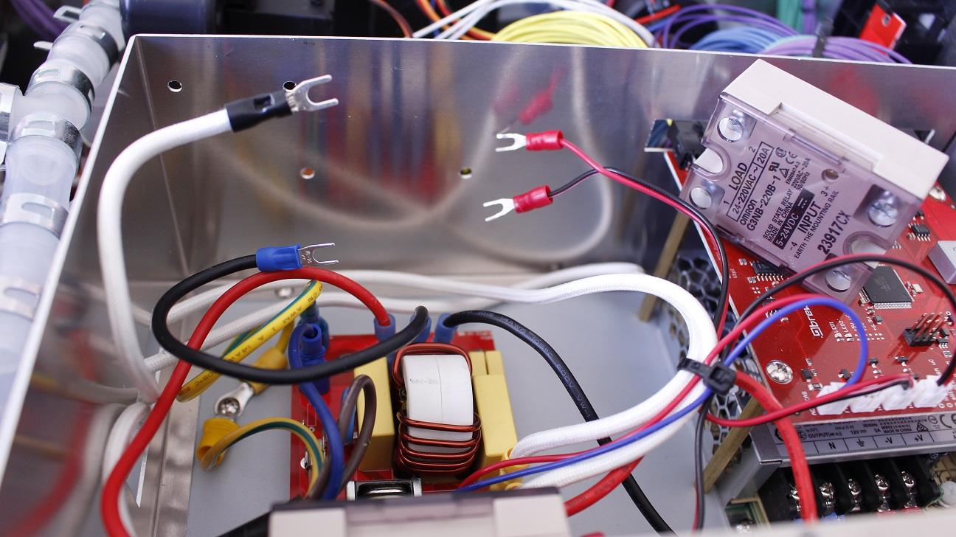

Reassemble consists of the same steps in reverse.